## Text Data:

Here I am using the same project that I have created for Image classification AutoML.

1. Project id: hw2p1-image

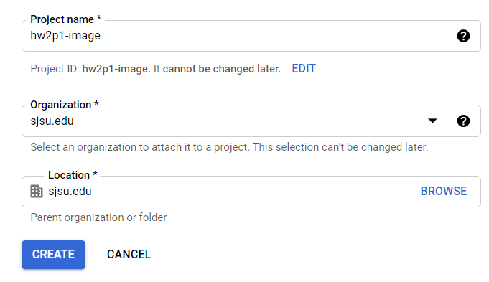

1. API is enabled

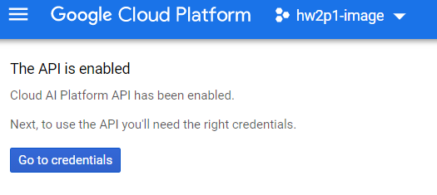

1. Authentication Setup

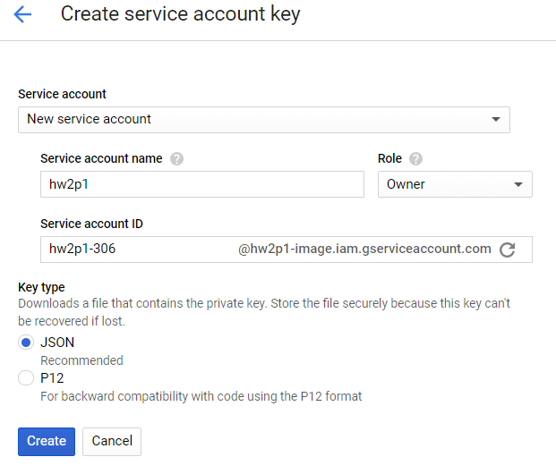

1. Set environment variable

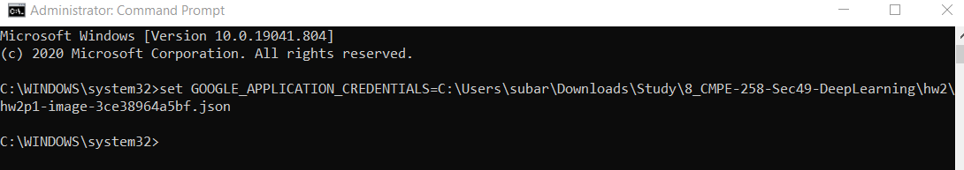

1. Cloud Console:

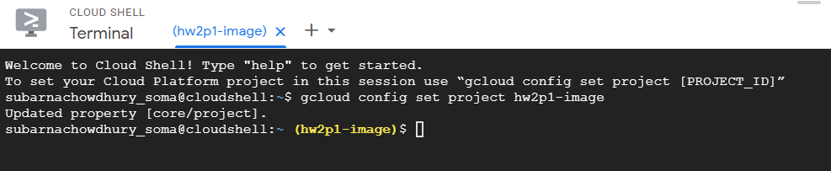

1. Created Google Cloud Storage Bucket

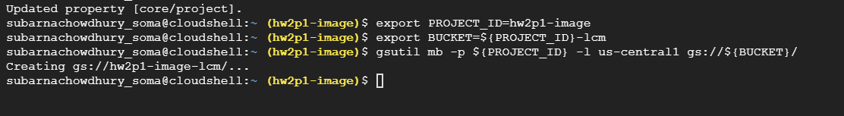

1. Copying data set to storage:



1. Create Dataset ‘hw2p1-text_classification’

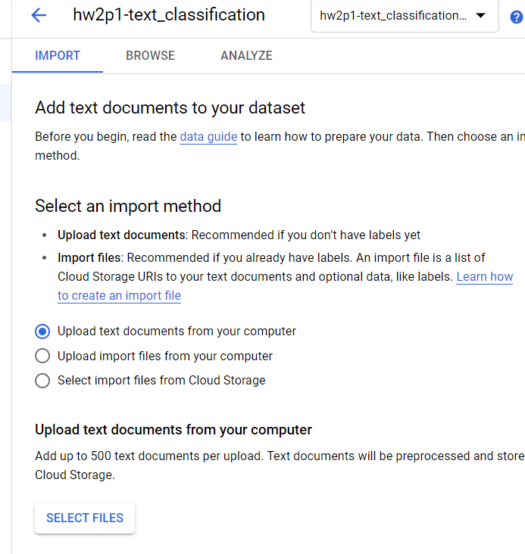

1. Import Data from Storage

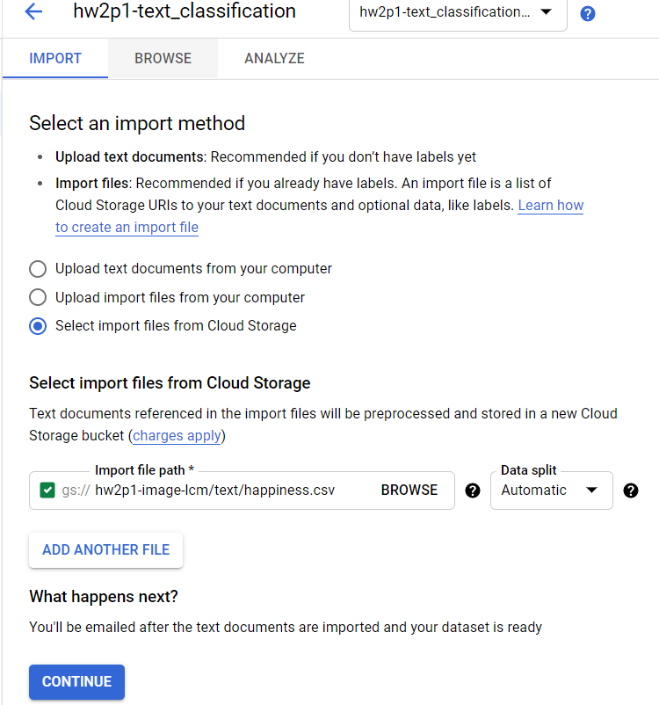

1. Finished Importing Data

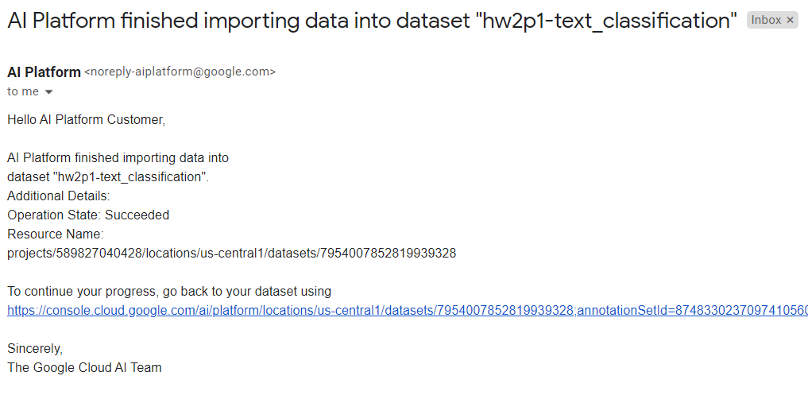

1. Created model ‘hw2p1-textdata_model’ and Selecting Training Model:

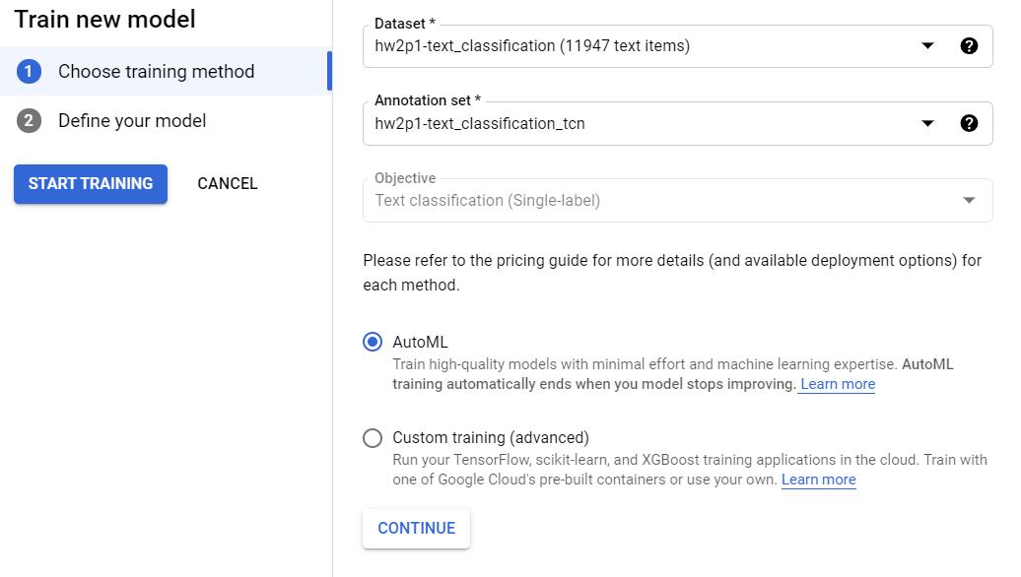

1. Got Email Notification about successful training

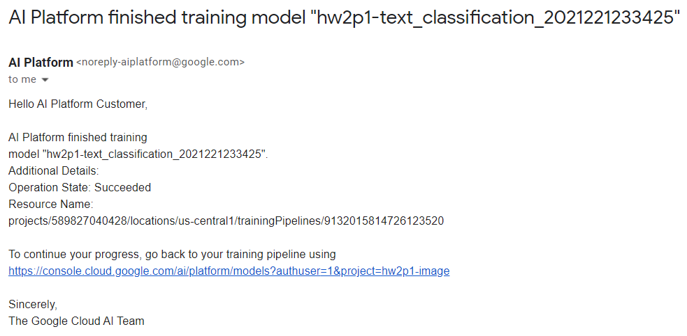

1. Trained Model: It has taken 4+ hours to train

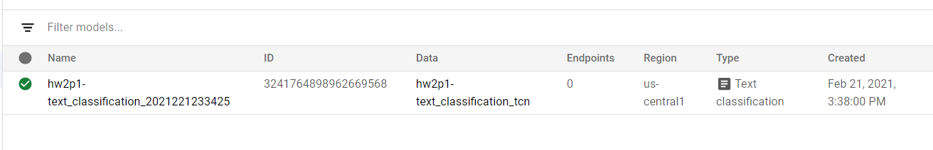

1. Evaluation

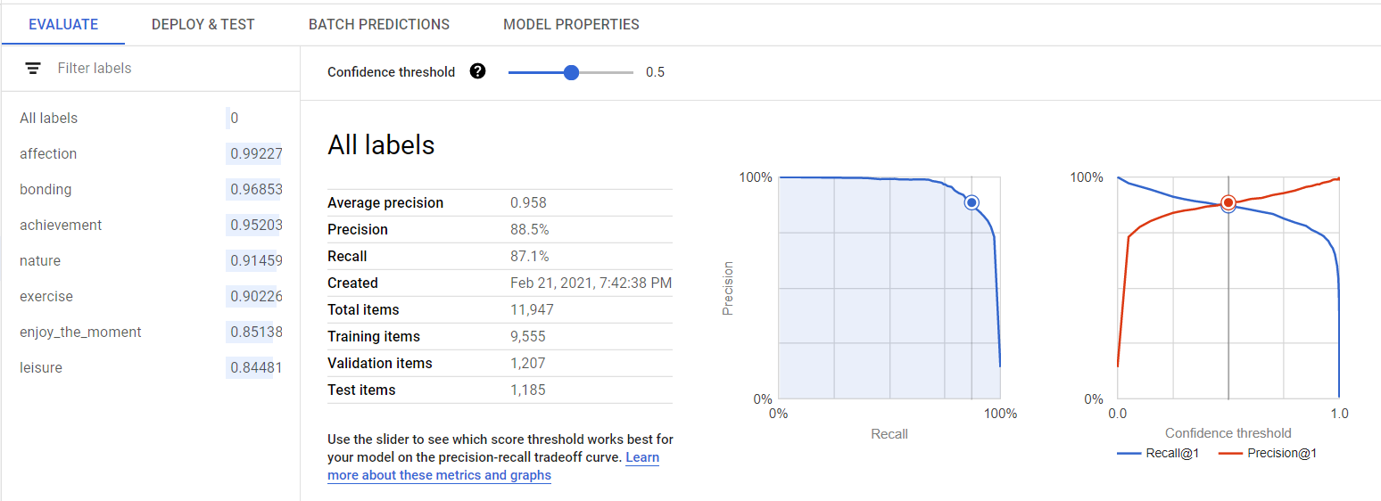

1. Confusion Matrix

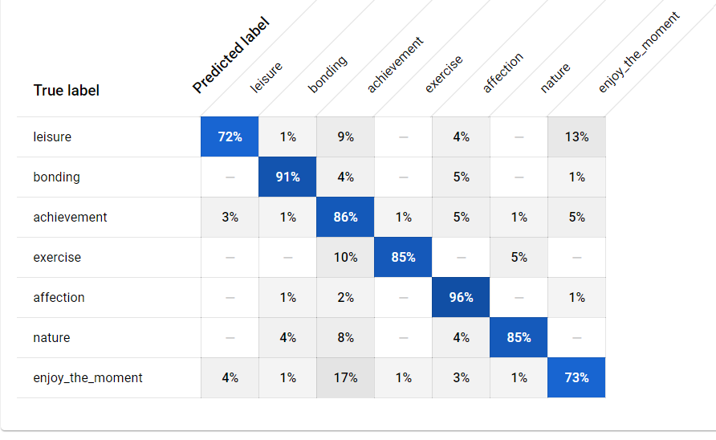

1. Created Deployment Endpoint ‘hw2p2-hello_automl_text’

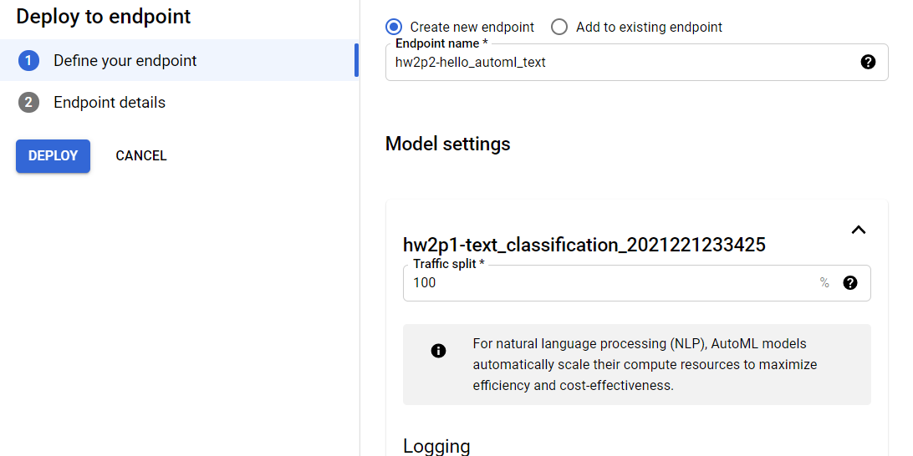

1. Successful Deployment

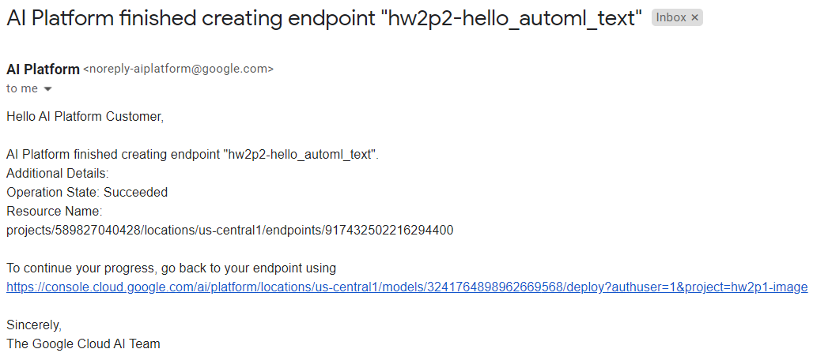

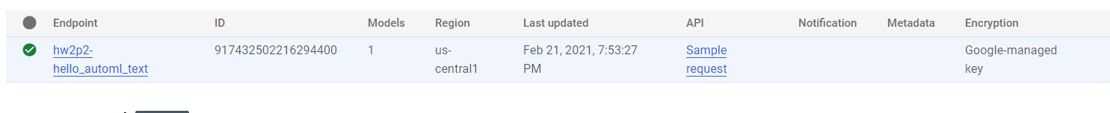

1. Prediction 100% Correct

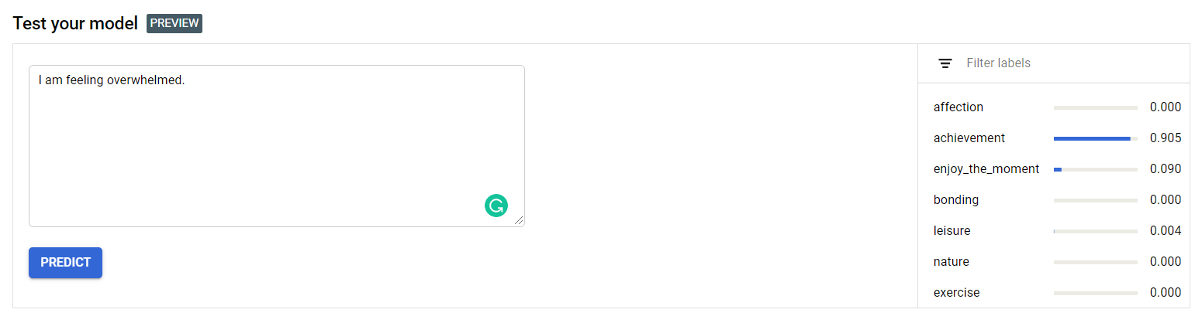

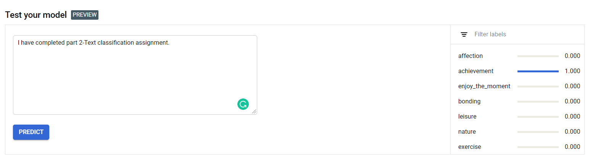

1. Removed Storage

